**Solution Document**

**Assumptions**

* The quantity will be always in Kg. i.e 23.0 Kg.
* Price can be input like : £ 12, £21, 323 £.
* User Id will always string.
* Price and quantity will also be string.
* Order type should be **BUY** or **SELL**.

**Steps to run**

1. This is a gradle project to build the project in develop environment use command **gradle bootRun**.
2. To build the project and create jar file which will be found in build->libs folder

**gradle build**.ss

1. To clean the build use below command.

**gradle clean**

1. To run the JAR file use below command.

Java –jar <filename.jar>

**Alternative approach**

* We can use in memory database like H2 instead Map and ArrayList just to avoid operations for bulk data.
* For API documentation we could have used the SwaggerUI to make the development more robust.

**Running application using Docker container**

* To run the application on a docker container environment copy the JAR file, Dockerfile and docker-compose.yml file in the cloud instance in side a folder named SBM-docker.
* Install docker compose and docker on the cloud environment.
* Go inside the folder by doing cd and then run the below command to up the container

docker-compose up –build

* Once the command ran successfully open POSTMAN and hit the <instance-name>:8080.

**API Details**

|  |  |  |  |
| --- | --- | --- | --- |
| **API** | **Method** | **Input** | **Output** |
| /api/v1/register | POST | {  "userId": "wilson",  "quantity": "2.5 Kg",  "pricePerKg": "£ 122",  "orderType": "BUY"  } | {  “status”: “OK”,  “payload”: [  {  "userId": "wilson",  "quantity": "2.5 Kg",  "pricePerKg": "£ 122",  "orderType": "BUY"  }  ]  } |
| /api/v1/cancel | DELETE | {  "userId": "wilson",  "quantity": "2.5 Kg",  "pricePerKg": "£ 122",  "orderType": "BUY"  } | {  “status”: “OK”,  “payload”: [  {  "userId": "Sam",  "quantity": "1.5 Kg",  "pricePerKg": "£ 122",  "orderType": "BUY"  }  ]  } |
| /api/v1/summary | GET |  | {  “status”: “OK”,  “payLoad”:  {  “BUY”: {  "userId": "wilson",  "quantity": "2.5 Kg",  "pricePerKg": "£ 122",  "orderType": "BUY"  },  “SELL” : {  "userId": "wilson",  "quantity": "2.5 Kg",  "pricePerKg": "£ 122",  "orderType": "BUY"  }  }  } |

**Input data Example:**

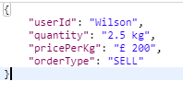

**Output data Example:**

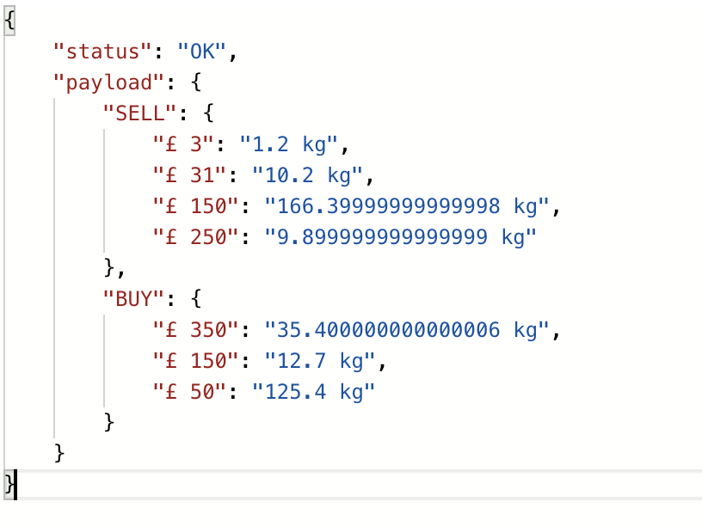

**Code coverage**

